How to extend your wireless work by button
Product line: Wireless Model number: A9

By pressing the EXTENDER button, we can achieve wireless bridging for extending wireless network without complicated procedure . Before setting A9, please make sure that you can get internet if you connect your computer to upper router directly and the mainrouter has a WPS hardware button.

Steps are as follow:

- Press the WPS of your mainrouter for 1-3 seconds，it’s WPS light should be blinking. If the WPS light of mainrouter does not come out ，please login router homepage to enable it manually.
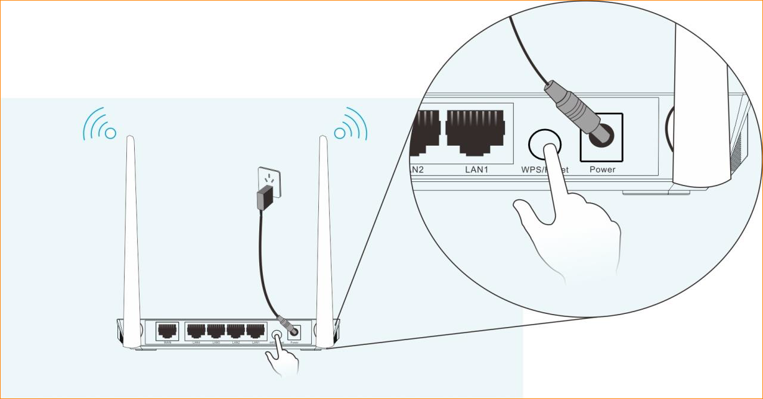
- Press the extender’s WPS button ( Indicator is the wps button ) on the A9 twice quickly in one second，then extender’s light should be bright for 2 seconds and then flash quickly
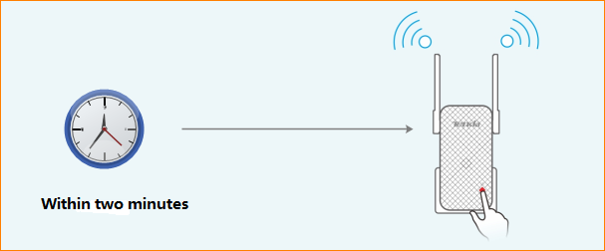
- When the Extender LED is solid green or solid orange or flashing orange, the Extender is successfully connected to the router. You can also login to the extender’s web management interface to check bridge status.

Note： Our Range extender can only work fine with those routers which can support the standard of WPS 2.0. If you failed to bridge your wireless network by pressing the button of A9,we recommend you to set the wireless network mode of mainrouter as unencrypted or WPA2-PSK or mixed WPA2-PSK/WPA-PSK or extend your wireless via management page.

